Design Rationale
Key Architecture of Code
CardGame is responsible for the main game logic and management. It parses the input data, validates the data, initializes the ring topology and manages the thread execution. Other classes do what they should do and nothing more. This keeps everything clear, secure and encapsulated.
Player is the main work horse of the card game. It implements runnable and manages its own localized game loop. It interacts with shared resources like Deck and Hand.
Deck is a thread safe container for Card objects to be stored and allows access concurrently by Players.
Hand encapsulates the logic of holding a player's cards, verifying wins and selecting non preferred cards to discard.
Card is immutable. It holds value and cardId preventing accidental change across threads.
Concurrency Decisions and Thread Safety
The main challenge we faced during this specification was ensuring drawing a card from the left deck and discarding it to the right deck was on singular atomic action.
We started by using a LinkedBlockingQueue because it handles the thread safety using put() and take() easily. However this didn’t guarantee that draw and discard would happen together without issues. So instead we are using ArrayDeque and ReentrantLock. This allows a Player thread to aquire access to their left and right decks at the same time before modifying either and ensuring atomic actions.
We also use AtomicBoolean across all threads. This ensures once one player thread wins, all other threads see this and can exit easily.
Object Orientated Design
To satisfy the requirement that a game must not stagnate, the Hand class uses Random to select from all non preferred cards.
Using encapsulation, we also created custom runtime exceptions to implement fail solutions and communicate them effectively.
We have separated the Hand and Deck classes as the Deck requires FIFO and a Hand requires random access.
Known Limitations
Because adjacent players share decks, which lock twice per turn, at a large game e.g. n = 10000, these locks may lead to bottleneck and performance could drop dramatically.
Testing

Pair Programming
Date | Time | Commit Description | Driver | Navigator
October 13th | 15:00 | Initial file structure and class setup. Maven tests functioning. | John | Russell
October 14th | 14:25 | Continue work on multiple classes. Thoughts of extending Deck class with a Pack class which can be used in initialization of game. | John | Russell
October 16th | 12:15 | Added key Player logic and finished Deck methods. | Russell | John
October 16th | 18:00 | Worked on Hand, Player and Deck interlink and security between classes. | John | Russell
October 18th | 18:13 | Added randomness to Hand, add file logging and finished methods. | Russell | John
October 18th | 23:16 | Found syntax errors, missing functions and comment formatting. | John | Russell
October 19th | 11:26 | Add start game method and user input requests. | Russell | John
October 19th | 23:49 | Completed CardGame, created exceptions, nearly at testing stage. | John | Russell
October 20th | 00:53 | Fixed bugs, fixed deadlock, ran tests on classes. | John | Russell

All classes were tested with Junit 5 / Maven to ensure the discarding / drawing logic followed the strcuture outlined in the sepcification. The pack subclass was also tested to ensure that it loaded the pack file correctly and throws the correct exceptions if something goes wrong. Additionally, the CardGame class was tested with varying amounts of players to get a better idea about its efficiency. The results were plotted using pyplot:
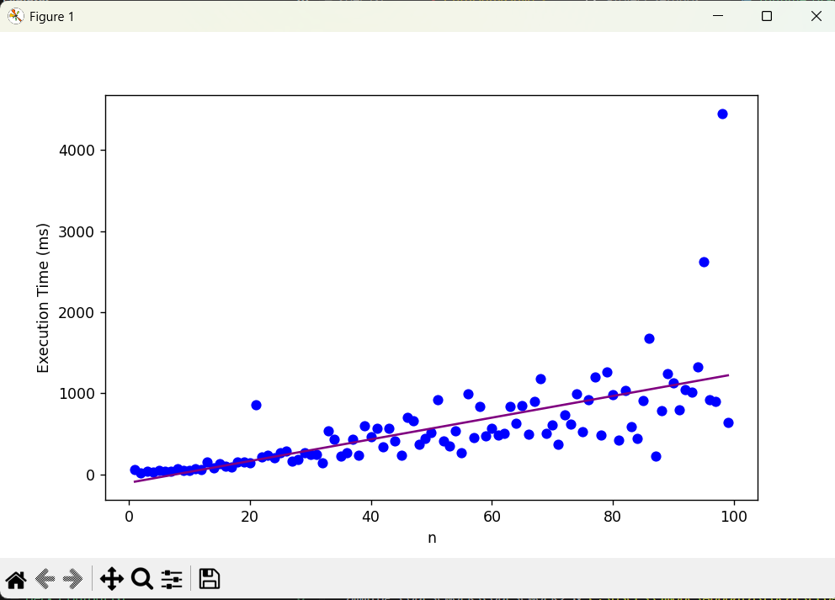

The graph shows that the program executes in O(n) where n is the number of players. It appears that the variance in runtime increases rapidly beyond n=30, however stays fairly consistent below this threshold.

